Weekly report

1. **My *Goals* from last week**
   * Objective 1: Make a new tilting frame with a longer moment arm and ball bearings
   * Objective 2: Run coefficient of restitution experiment on several materials
2. **My *Accomplishments* this week**
   1. Objective 1:
      1. Made the new frame. It looks great; the only issue is that the rotating bar tends to bend towards one of the plates, creating a lot of friction. This iteration is shown in Figure 1

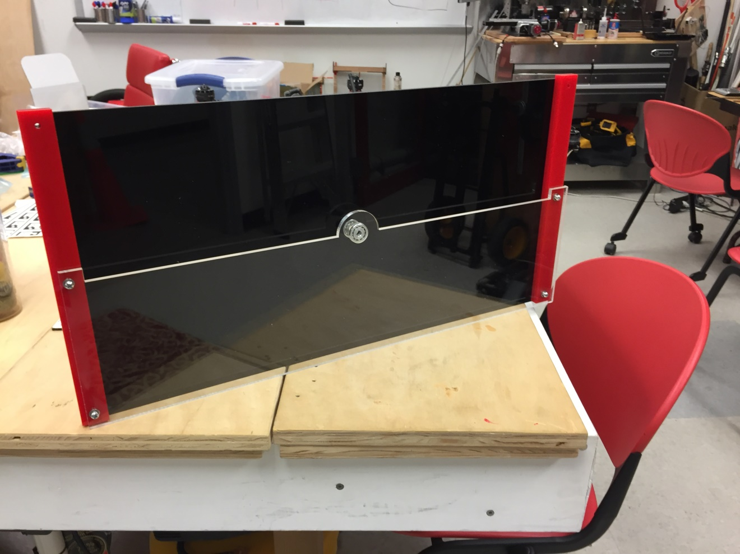

Figure 1. New tilting frame

* 1. Objective 2:
     1. Jarrett and I cut all of the rod samples (15). All samples are around 15mm long; the exact lengths are recorded as we test each of them. 5mm of sample stick out of the chuck during the tests.
     2. We are done with two-thirds of the experiment, only the samples with the biggest diameter are left to test. Figures 2 to 4 depict stages of the experiment.

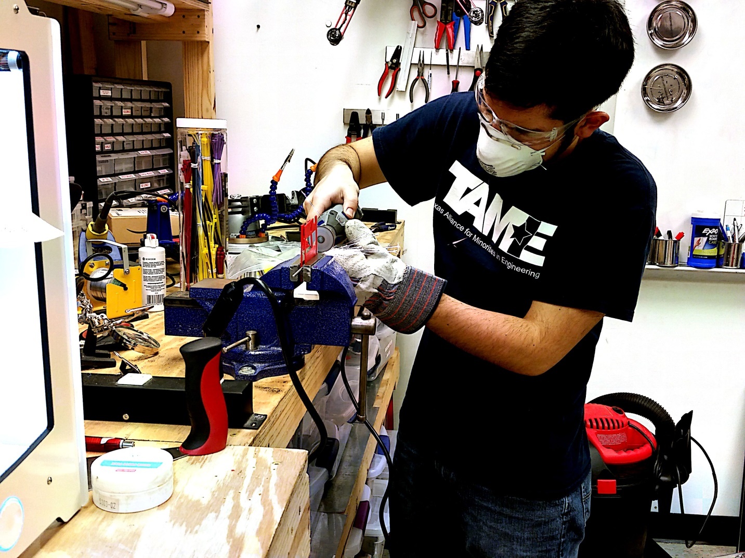

Figure 2. Safely cutting metal samples

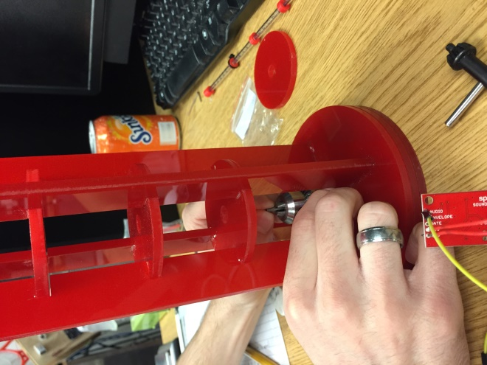 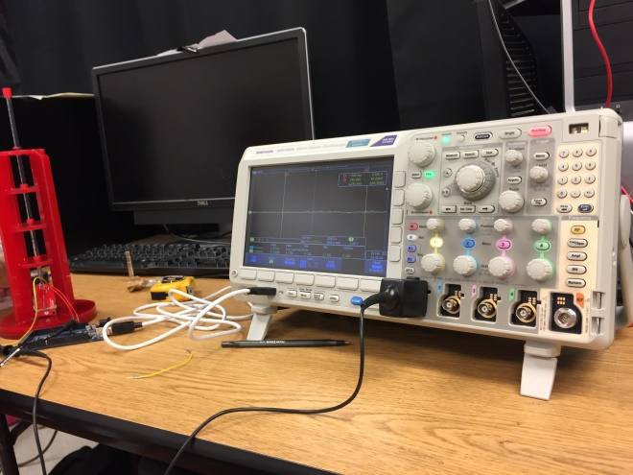

Figure 3. Experiment in progress

1. **My *Goals* for next week**
   * Tilting frame

* Fix the rotating bar so it doesn’t hit the plates when spinning. Look up potential particles (balls, cubes, etc.) for testing on Amazon
* Coefficient of restitution experiment
* Finish the experiment and analyze the data
* MRI compatible Gauss Gun
* Start prototyping with the 3D printer

1. **What I need Dr. Becker to do:**
   * Nothing for now